

**Polli Shahajogir Bishawyk Sangstha (ARCO)**

**(Association for Rural Cooperation)**

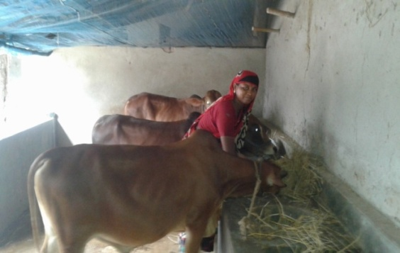

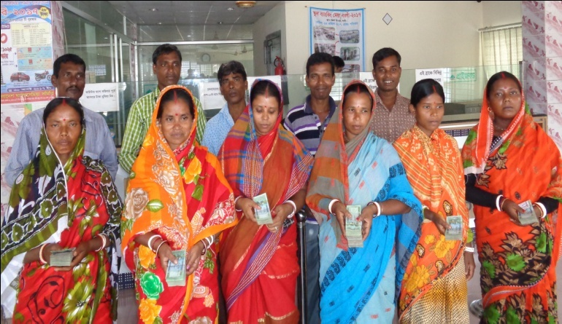

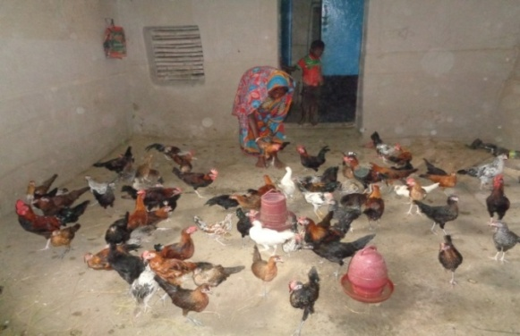

**Association for Rural Cooperation (ARCO)**

Boalia, Naogaon

email : [arco.bangladesh@gmail.com](mailto:arco.bangladesh@gmail.com); 65sajal@gmail.com

**Brief history of development journey:**

ARCO is a non-profit making NGO working for the deprived and most disadvantaged poor communities, especially Adibashi and Dalit communities of plain land. It started its interventions with emergency response to the extreme affected people of Joypurhat, Naogaon, Bagura, Natore, Rajshahi districts of Bangladesh during September, 1995. It was appeared by some young and energetic activists through a general meeting on February, 1996, where they undertook long term development initiatives with a mandate to **developing a society free from hunger and poverty, where the people’s rights are heighted.** It was registered under Department of Social Welfare on 23 June, 1997 to reach its mandate. Then it was registered under NGO affairs bureau on 8 Nov, 1999 as per development needs.

ARCO was established as a voluntary organization by some young and energetic activists. The successful voluntary interventions tracked it towards undertaking the development activities for the most vulnerable, deprived, and marginal people, especially *Adibashi* and *Dalits* people. Now it has been working with the communities, which especially focus on leadership development, advocacy for services, rights and entitlements from government and non-government institutions, linkage building with service providers & market actors, livelihood promotion for increasing regular income, value chain of bull fattening and native chickens, technical, vocational, and educational training with job placement of young women and men, transfer improved agro-technology for climate change adaptation, food security and nutrition promotion, gender development, peace and conflict management, disaster risks reduction, and resilience building through community & local government initiatives, entrepreneurship development, micro-finance and house building. Its ultimate goal is to improve the socio-economic status and social inclusion of the most vulnerable, deprived, and marginal communities, especially Adibahsi and Dalits communities at rural and urban settings.

**Philosophy:** ARCO beliefs that each people are capable to intervene something, but hindered by surroundings unfavorable environment. ARCO develops their invention power eliminating the surroundings environment.

**Year of Establishment: 2** February, 1996 through general meetings by some young and energetic social activists.

**Legal status:** ARCO is registered with social welfare, NGOAB, and Micro Credit Regulatory Authority.

|  |  |  |  |  |
| --- | --- | --- | --- | --- |
| **Sl. No.** | **Departments** | **Registration No.** | **Date** | **Remarks** |
|  | Department of Social Welfare | Naogaon-366 | 23/06/1997 |  |
|  | NGO Affairs Bureau | 1443 | 08/11/1999 |  |
|  | Micro Credit Regulatory Authority | 00984-01198-00193 | 25/3/2008 |  |
|  | National Board of Revenue | 738747361654 | 28/03/2019 |  |

**Vision:** Developing a society free from hunger and poverty, where the people’s rights are heighted

**Mission:** Empowerment of the deprived and most disadvantaged poor communities, especially the women and children

**Goal:** Improve the quality of life of the poor, Hardcore poor, women, children, indigenous and disable people of the society.

**Fundamental principle:** Transparency and accountability, Autonomy, Non-discrimination, and Gender Equality.

**Objective:**

* To increase the accessibility of poor, hardcore poor, the disadvantaged, women and children in mainstream programs.
* To ensure the basic rights of the people.
* To undertake and implement of suitable projects for poor people.
* To Increase the capacity of women by increasing their skills.
* To ensure the child's survival, safety, development and participation rights.
* Taking steps to help prevent HIV / AIDS and other diseases.

**Interventions:**

* Develop community-based organization and leadership of Adibashi and Dalits people through democratic practices, values and development framework initiatives
* Mobilize the community for the protection of women and children
* Conduct advocacy, mass awareness and campaign for security, protection and fulfillment of the rights of Adibashi, Dalits, women and children,
* Develop the life skills of Adolescent and youths
* Promote health and sanitation conditions of Adibashi and Dalits communities
* Promote demand-oriented livelihoods for the deprived and most disadvantaged poor communities, especially Adibashi and Dalits
* Create opportunities for education, technical and vocational training with job placement
* Coordinate the market development activities of small farmers
* Engage private and public sectors for inclusive market development
* Improve, transfer, and integrate advance agro-technology and climate change adaptation (CCA) strategies
* Food security and agriculture assistance to small holder farmers
* Build the capacity of farmers to mitigate upcoming challenges of climate change on livelihoods and environment
* Capacitate the community, local government & staff on anticipation of climate change impact, humanitarian aid management and disaster risks reductions (DRR)

**Strategies:**

* Development of leadership, CBOs and institutional capacity for claiming rights and entitlements
* Promotion of education, health and sanitation
* Promotion of livelihoods and economic status
* Extension and transformation of information and technology
* Sustainable agriculture, food security and resource management

**Implemented programs**

* Access to services, rights and entitlements of Government and non-government institutions
* Agriculture and food security assistance
* Inclusive market development of Agriculture and Non-agriculture products (bull fattening and native chickens, vermi compost)
* Promotion of public health and sanitation
* Climate change adaptation and disaster risk reduction
* Housing
* Blood donation
* Combat and control of Alcohol
* Micro finance for sustainable development

Targeted population: The most disadvantaged, deprived, and marginal communities, especially Adibashi and Dalits communities

|  |  |  |  |  |
| --- | --- | --- | --- | --- |
| **Year** | **Household** | **Male** | **Female** | **Total** |
| 2017 | 18,688 | 46,427 | 47,013 | 93,440 |
| 2018-2021 | 41,280 | 10,2554 | 103,846 | 206,400 |

**Program Approach**

* Democratic
* Human Rights based
* Partnership and networking
* Systemic change
* Inclusive Market Development
* Diapraxis

**Cross cutting issue**

* Gender
* Resilience building
* Conflict management

**Development theory of Change:**

**Organizational standards and procedures:** ARCO has formal oversight mechanism and the following approved policies and manuals to govern and manage organization and its development programmes for formally established internal procedures and mechanism for handling legal affairs.

* Human Resource Policy
* Financial Policy
* Micro credit policies
* Gender policy
* Child protection policy
* Purchase and Sales Principles
* Principles of Sustainable Asset Management
* Savings and Credit policies

The policies entitle and direct the procedures of Accounting, Personnel Management, Leave Management, Procurement and Store & Internal Audit Manual etc.

ARCO has Gender Committee, Complain Management Committee, Disaster Management Committee, Purchase Committee, and Information Management Committee for smooth functioning of its governance.

**Leadership and Governance:** Executive Committee Members and Status of Kinship relation among the board members. Written Disclosure

ARCO has a general committee consisted of 27 members, of which six (6) are female and twenty one (21) are male from different backgrounds. Under the general committee, it has an executive committee consisted of 9 members from different backgrounds of which three (3) are female and five (5) male.

|  |  |  |  |  |  |
| --- | --- | --- | --- | --- | --- |
| Sl. No | Name | Father/Husband name | Designation | Address | Remarks |
|  | Md. Jahangir Islam | Khademul Islam | President | Khash Naogaon |  |
|  | Md. Bazlar Rahman | Late Bazu Sarder | Vice President | Boalia Naogaon |  |
|  | Sajal Kumar Chowdhuri | Late Satish Chandra Chowdhuri | General Secretary | Per-Naogaon |  |
|  | Aroti Pahan | Shushil Pahan | Vice General Secretary | Baromohespur, Mohadevpur, Naogaon |  |
|  | Bishawjit Mozumdar | Brazandra Nath Mozumdar | Treasurer | Per Naogaon, Naogaon |  |
|  | Md. Abed Ali Dawyan | Late Kandur Dawyan | Executive Member | Boalia, Naogaon |  |
|  | Sazadul Islam | Md. Mozafar Hossain | Executive Member | Khalishakuri, Naogaon |  |
|  | Mst. Rebeka Sultana | Late Shahidul Islam | Executive Member | Boalia, Naogaon |  |
|  | Mst. Hasna Rani | FM Mamatazur Rahman | Executive Member | Dhamkuri, Santahar, Naogaon |  |

**Organigramme**

General Committee

Executive Committee

Advisory Committee

Executive Director

Manager, Monitoring and Evaluation

Coordinator

I CT Officer

Monitoring officer

Field

Organizer

Market Development Manager

Manager, Micro Finance

Coordinator

Program Manager

Accounts officer

Peon/Guard

Driver

Manager, Finance and Admin

Coordinator

Admin

Officer

Market Development Officer

Project Officer

Training Officer

Micro-credit Officer

Advocacy Officer

Community Facilitators/Organizers

Field Organizer

Community

Volunteers

Field

Organizer

Field

**Income sources of Organization:** ARCO creates fund for its development work from

* **INGO:** HEKS/EPER and
* Mennonite Center Committee (MCC) Bangladesh
* **Government :** Bangladesh Bank
* **Own :** Micro-credit
* Like minded NGOs
* Contribution of members
* Start Fund Bangladesh/ UK aid

**Human resources**

|  |  |  |  |  |  |
| --- | --- | --- | --- | --- | --- |
| Permanent staff | | | Volunteer | | |
| Total | Female | Male | Total | Female | Male |
| 45 | 25 | 20 | 50 | 25 | 15 |

**Previous and ongoing project**

|  |  |  |  |  |
| --- | --- | --- | --- | --- |
| **Sl. No.** | **Project/program's name** | **Donor** | **Year** | **Total budget** |
|  | Dalit/Adibashi Rights, Empowerment and Access towards Mainstreaming (DREAM) | HEKS/EPER, Switzerland | 2017-2020 | 6,95,64,212 |
|  | ARCO Agriculture and food security assistance project. | M. C. C. Bangladesh | 2017-2020 | 34,62,000 |
|  | Housing project | Bangladesh Bank | 2008 ---continue | 69,30,000 |
|  | Micro Finance | Own | Ongoing | 1,75,0000 |

**Working location:**

|  |  |  |
| --- | --- | --- |
| **District** | **Upazila** | **union** |
| Naogaon | Naogaon Sadar | Boalia Union  Tilokpur union  Naogaon Pourashava |
| Mohadevpur | Cheragpur union  Mohadevpur sadar union |
| Patnitala | Patnitala union  Patichara union |
| Borga | Adamdhigi | Santahar Pourashava |

**Office Address:** ARCO has officially designated persons to represent any specific constituency

|  |  |  |
| --- | --- | --- |
| **District** | **Upazilla/Union** | **Office Address** |
| Naogaon | Naogaon Sadar | Head Office,  Boalia, Naogaon-5600 |
| Mohadevpur Upazilla | ARCO Project Officer  Nearby Police Station  Mohadevpur Sadar  Mohadevpur, Naogaon |
| Patnitala Upazilla | ARCO office  Naogaon Bustand, Padma counter, 2nd Floor, Nazirpur, Naogaon |
| Cheragpur Union | ARCO Office  Dhanjoil bazar,Cheragpur,Mohadevpur,Naogaon |

**Membership and networking:**

ARCO is a member of

* Credit and Development Forum (CDF)
* The Network of Non-mainstreamed Marginalized Communities-NNMC Foundation.
* Federation of NGOs in Bangladesh (FNB),
* Action Against Trafficking and Sexual Exploitation of Children (ATSEC-Bangladesh) and

|  |  |  |  |  |  |  |  |  |
| --- | --- | --- | --- | --- | --- | --- | --- | --- |
| Sl.No | Name | Designation | Date of birth | Father's Name | Permanent Address | Name of Spouse | Educational Qualification | Profession |
| 1 | Md. Jahangir Islam, | president | 26-01-1963 | Md. Khadamul Islam | Khas Naogaon, Naogaon 6500 | Naz A Shabera | L.L.B | Lawer. Judge court. Naogaon |
| 2 | Md. Bozlar Rahman, | Vice-President | 23.12.1956 | Late,Bazu Mondal | Boalia, Naogaon, 5891 | Mst. Asrafun Nesha | B. A | Asst. Teacher, Boalia High School, Boalia, Naogaon |
| 3 | Sajal Kumar Chowdhury, | General Secretary | 11.10.1965 | Late. Satish Chandra Chowdhury | Per-Naogaon, Naogaon,6500 | Bharati Rani | M. Sc.Ag | Executive Director, ARCO |
| 4 | Aroti Pahan, | Vice-General Secretary | 14.04.1976 | kashi nath pahan | Boro mohespur,Cheragpur, Mohadevpur, Naogaon. | Shusil Pahan | S.S.C | Social Worker |
| 5 | Biswajit Majumder, | Treasurer | 01.12.1975 | Brozendranath Majumdar | Per-Naogaon, Naogaon,6500 | Lipi Rani Majumder | M.A | Head Teacher, Boalia High School, Boalia, Naogaon |
| 6 | Md. Abed Ali Dewan, | Executive Member | 02.01.1946 | Kandur Dewan | Vatara,Gulshan,Dhaka 1212 | Mst. Sahida Banue | B. A | Ret. Managing Director (admin) |
| 7 | Md. Sajedul Islam, | Executive Member | 4/2/1976 | Md:Mozaffar Hossen. | Khalisha Kuri,Naogaon,6500 | Hosne ara Begum Sumi. | B.A | Principal, VLC Kinder garten School. |
| 8 | Msr. Rebaka Sultana, | Executive Member | 01.01.1984 | Hossain Ali | Boalia, Naogaon,5891 | late,Sahidul Haque | S. S. C | Counselor, Naogaon Municipality |
| 9 | Miss.Hasna Banu | Executive Member | 1/1/1964 | Md. Abdul Ghofur Mondoul | Dham Kuri,Santahar,Adamdhighi,5800 | AFM Momtazur Rahman | B.A | Head Teacher, Dhamkuri Govt: primary School. |